‘Fractured Care’ – An Evaluation of Rib Fracture Management in a new Major Trauma Centre
Thomson. R, Patterson. C, Acute Pain Service

Introduction
The aetiology of patients presenting to hospital with rib fractures varies from the simple fall in the elderly, to the major trauma requiring immediate medical and surgical intervention.
With mortality rates up to 12% and pulmonary complication rates 35%, these patients can require complex medical and analgesic interventions.

Aberdeen Royal Infirmary (ARI) currently has no definitive clinical pathway for this “at risk” group of patients despite being commissioned as a Scottish Major Trauma Centre in October 2018.
This project aims to evaluate the current initial management of patients presenting to ARI with rib fractures, with assessment of the number of patients requiring ventilatory support, and the present utilisation of regional analgesic techniques.

Methods
Demographic and clinical data was prospectively collected on all patients presenting to the adult emergency department at ARI with rib fractures between 1st November 2018 to the 1st February 2019 (n = 29), regardless of aetiology.
Of the patients admitted to hospital (n = 20) a ‘rib fracture score’ was calculated, with initial analgesia and ward of admission compared to that recommended in the attached flowchart (Table 1).
Data on respiratory deterioration, requirement for ventilatory support, and use of regional analgesia techniques was collected by the acute pain nurses in the subsequent days.
Simple descriptive analysis was performed and presented using Microsoft Excel 365TM

Results
The average age of the 20 patients admitted to hospital (14 male, 6 female) was calculated at 63.95 years.
According to the rib fracture score, 15% (3/20) of patients were admitted to an ‘inappropriate ward’ – e.g. level 1 over level 2 care.
In 40% (8/20) of cases initial analgesia did not match that recommended by the rib fracture pathway.
20% (4/20) of patients deteriorated due to respiratory failure, requiring additional ventilatory support, and 25 % (5/20) of patients had a regional technique for rescue analgesic intervention.

Conclusions
Our data set has quantified variability in acute rib fracture management, specifically regarding analgesia prescription and patient placement on admission.
To address this problem, we have suggested a standard inter-departmental admission pathway based on Figure 1., with linked email referral service alerting the acute pain team. Our aim is to highlight these ‘at risk’ patients earlier, allowing for optimisation of analgesia, reducing the potential for pulmonary complications.

At present, the use of regional analgesia is mainly limited to those with a deteriorating respiratory pattern, often dependant on the skill-set of the available anaesthetist.
A new local ‘rib-rescue’ course has been developed to fill this knowledge gap, teaching relevant fascial plane blocks to consultants and trainees, aiming to offer a 24-hour rib fracture analgesia service.

Table 1 – Rib Fracture Management Pathway³
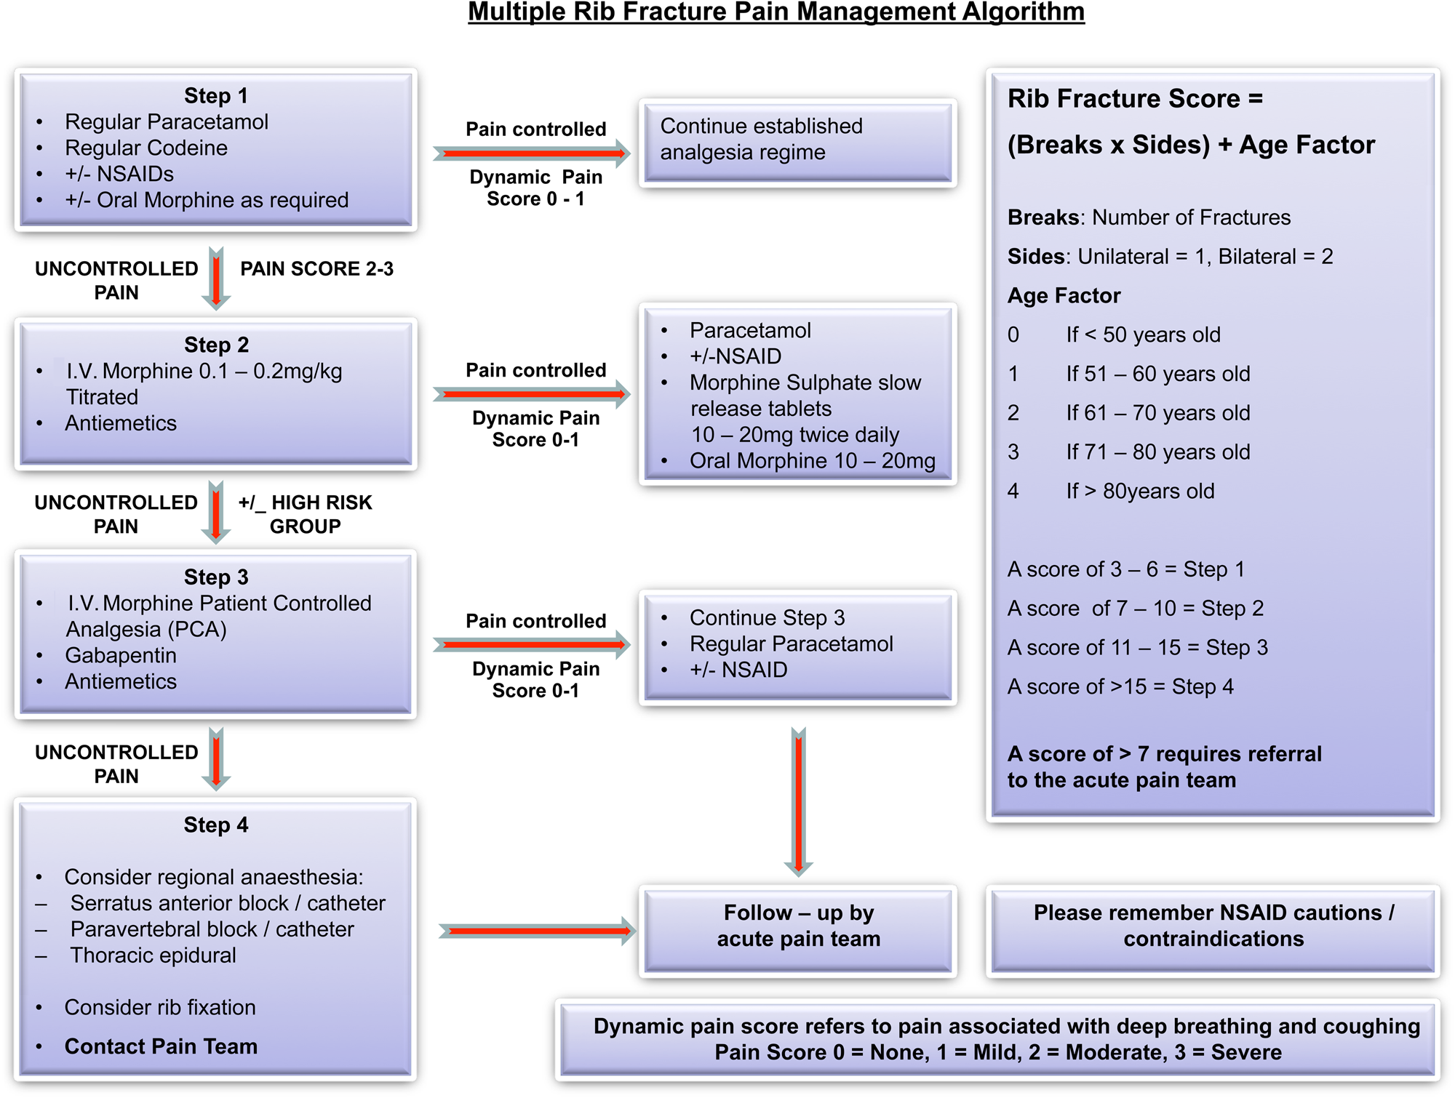

Ziegler DW, Agarwal NN: The morbidity and mortality of rib fractures; J Trauma. Dec 1994 ;37(6) pp 975-9
https://www.scottishtraumanetwork.com/wp-content/uploads/2018/10/Go-Live-FLASH-09Oct18.pdf
May. L, Hillermann. C, Patil. S, Rib fracture management, BJA Education, Volume 16, Issue 1, January 2016, Pages 26–32

