Does Preoperative Psychology intervention affect outcomes in hip and knee arthroplasty patients?

Background
Our project links effectively with “Perioperative Medicine – The Pathway to Better Surgical Care” (2015)¹. This document highlights the need to reduce the impact of acute pain after surgery.

Aim and Objectives
AIM:
To investigate whether preoperative psychological intervention improves patient experience and reduces length of stay in patients undergoing hip and knee arthroplasty.

OBJECTIVES:
- Identify patients preoperatively at increased risk of developing high levels of postoperative pain.
- Offer high risk patients psychological support to improve anxiety, mood and expectations of surgery.
- Assess impact on patient experience, delayed mobilisation and length of hospital admission.

Method
Successful application to the Health Foundation for an Innovation for Improvement award in 2016. We used Quality Improvement methodology. Other aspects of the patient pathway for hip and knee arthroplasty have remained unchanged, including a standardised anaesthetic and postoperative analgesia regime.

Before the project started, background data was collected using a PROP score (Preoperative Risk of Pain) and patients were given a score 1 to 4 (Table 1). Our scoring system was modified from the Kalkman Pain Prediction score.^{2,3}
Patients’ pain scores, length of hospital admission and reasons for delayed mobilisation and discharge were collected.

Once the project had commenced, patients with PROP scores 3 or 4 were offered preoperative psychological intervention. Psychology intervention is patient centred and consists of a maximum of three sessions. It consists of Modified Cognitive Behavioural Therapy (CBT), Mindfulness and Relaxation techniques.

During admission, patients’ pain scores, time to first mobilisation, GAD7 (anxiety score) and PHQ9 (depression score), patient satisfaction and length of hospital stay were collected.

Results

Baseline group n=66
Intervention group n=47

Interim results have shown a reduced length of stay in PROP 3 and 4 patients in our intervention group compared with baseline PROP 3 and 4 patients.

Mean length of stay in the baseline group was 142 hours compared with 108 hours in the intervention group. Using the Mann Whitney U test p value calculated as 0.044.

Pain as a reason for delayed mobilisation and delayed discharge has also decreased.

Patient feedback has been very positive. One patient commented, “Most people would feel anxious or concerned about a major operation and this experience was a safe place to voice and discuss those concerns. I found it extremely useful and calming and wouldn’t hesitate to recommend it to others.”

Conclusions

Providing psychology for high risk patients has been beneficial in improving patient experience and has lead to reductions in length of hospital admission.

We have been successful in developing a business case to sustain this project. We will be employing a Psychologist in our Trust with the cost savings released from shorter inpatient admissions.

References
1. ”Perioperative Medicine – The Pathway to Better Surgical Care” Royal College Anaesthetists (2015)
2. Kalkman CJ, Visser K, Moen J et al Preoperative prediction of severe postoperative pain. Pain 2003; 105: 415-23
3. Janssen K, Kalkman CJ, Grobbee DE et al The risk of severe postoperative pain: modification and validation of a clinical prediction rule. Anesth Analg 2008; 107:1330-9

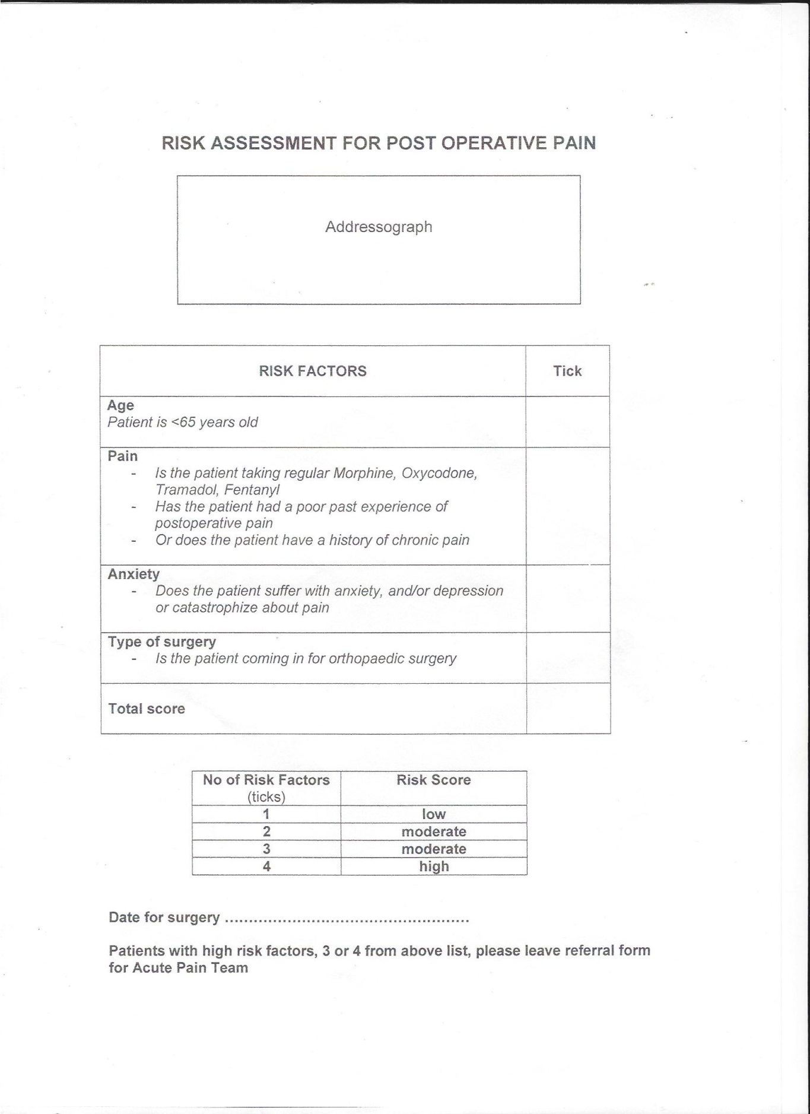
Table 1

