A recent study by Ismail et al (2012) reported patients’ opinion regarding postoperative pharmacological pain management was satisfactory in 91.6% of elective caesarian section patients and unsatisfactory in 8.4% of patients. However, 33% of patients reported moderate pain on movement (VAS 4-6) and 6.8% reported severe pain on movement (VAS 7-10).
The pain management conundrum;
Why do all patients not respond to acute pharmacological
pain management regimes?

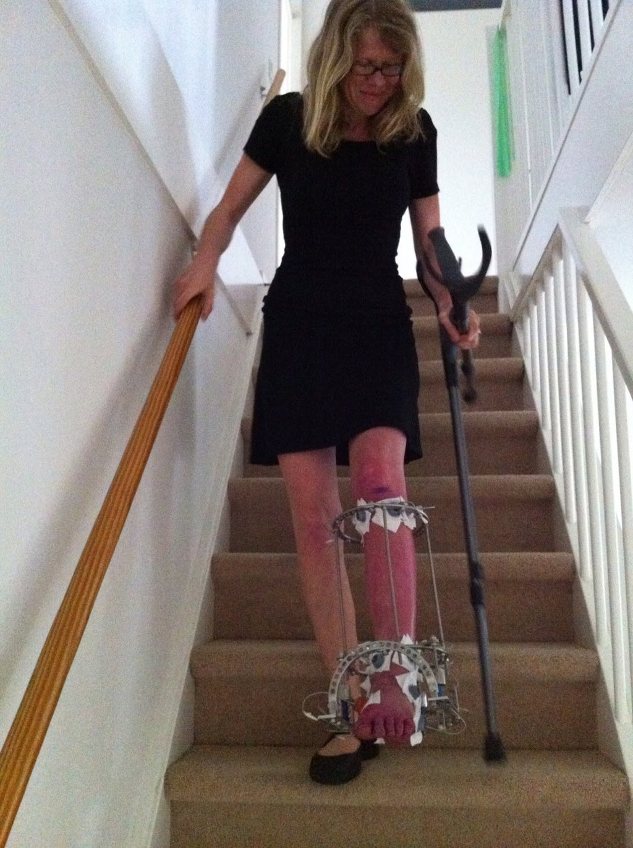
Of the patients not satisfied with pain management only 54% reported severe pain on movement (VAS 7-10). The remaining 46% reported only mild to moderate pain scores (VAS 1-6). There is no correlation made between the satisfaction levels of the patients in severe pain. This implies that patient satisfaction levels of pharmacological pain management are not necessarily influenced by pain scores with lower pain scoring patients reporting dissatisfaction.

Idvall (2012) explored this with 24 post op patients (10 General Surgery, 10 orthopaedic and 4 Gynaecology). Patients’ that reported severe pain scores (VAS 7-10) and high levels of satisfaction with pain management were questioned further on the reasoning for this which found the following influencing factors;

- Preoperative pain levels
- Patient expectations
- Patient’s perception of their pain
- External influences

Bostrum et al (1997) surveyed 100 patients on the second post-operative day. 79% reported moderate to severe pain although 83% were satisfied with the nursing staff treatment and management of their pain. Interestingly only 64% of the same patients were satisfied with the physician management of the same pain. This would indicate the relationships with healthcare professionals play an important role in patient satisfaction of pain management. This would be supported by the findings of Hunt (1995) who identified that although the nursing team required re-education in pharmacology of analgesia to better support patients post operatively, there were still high levels of patient satisfaction.
In addition to this fear is identified by Nelson (2013) significant determinant of unsuccessful pain management. In the acute post-operative patient this is a strong influencing factor particularly, when taking into account the visual component of pain with the association of fear. Fear avoidance and visual cues can quickly translate to emotional responses which are then more difficult to forget. If the processing and memory of pain becomes imbedded with a subsequent conditioned response, chronic pain patterns become increasingly likely.
The strategies employed by Allied Health Professionals (AHPs) integrate the benefits of pharmacology and interpersonal relationships. AHPs are often in a unique position whereby they are able to support patients in most of the areas identified by the research. This presentation will explore the interactions and treatment methods contributing to acute pain management of inpatients, whilst considering the physical, psychological and social influence on the experience of pain.

Justine Theaker. MSc, BSc (Hons), MSc (AP)
Clinical Therapy Lead and Advanced Practitioner, Central Manchester NHS Foundation Trust
Training Clinical Research Fellow, University of Manchester

